Vi Editor - Assignments
- Invoke the vi editor with a filename (which is to be created)
Vi nayu.txt
- Type a few lines(at least 10) in the editor. Let one or more lines contain the words given below.
delhi mumbai chennai Mumbai
- Save the file without exiting the editor
- :w
- Navigate quickly to the beginning & end of the file
- Beginning : gg
- End : G
- Delete first two lines & copy it after the last line
2dd
p.
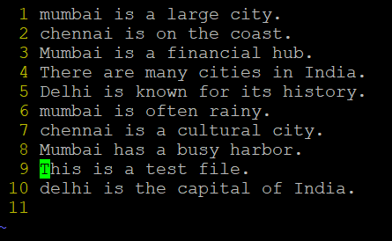
- Now Copy the last two lines & paste them before the first line.
2yy
p
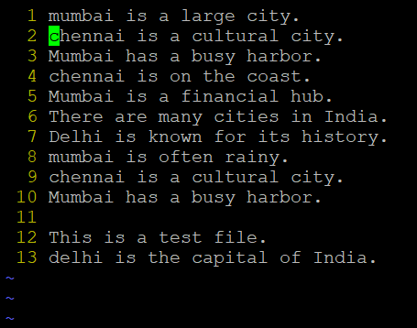
- Combine last two lines of the file in a single line.
G
J
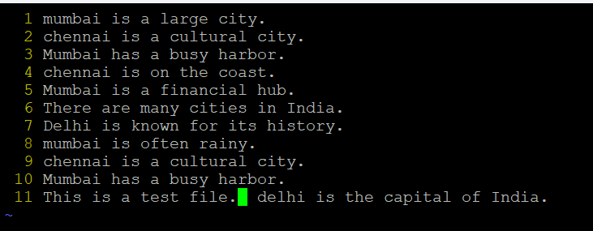
- How will you insert a line before the first line? (Hint : Find such an option in the tutorial document)
O
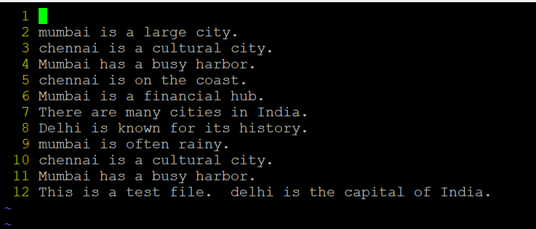
- How will you paste a yanked buffer before the current line?
p
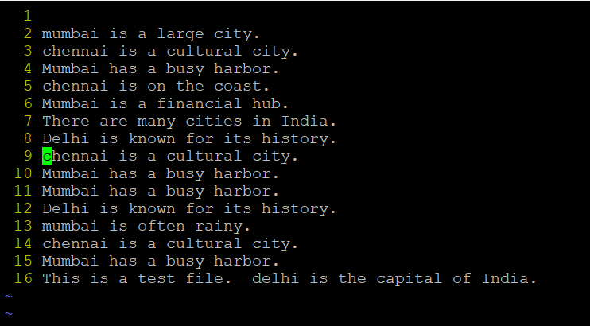
- Search the document for a string “delhi”
/delhi
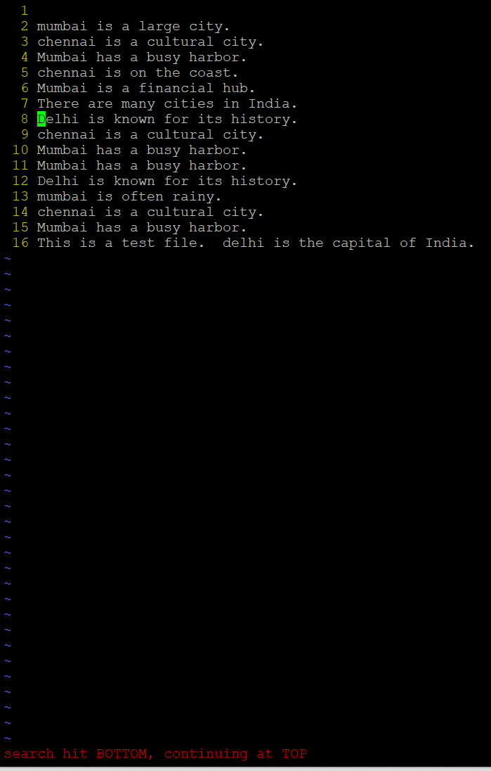
- Replace a single occurrence of “delhi” with “Mumbai”
:s/delhi/Mumbai/
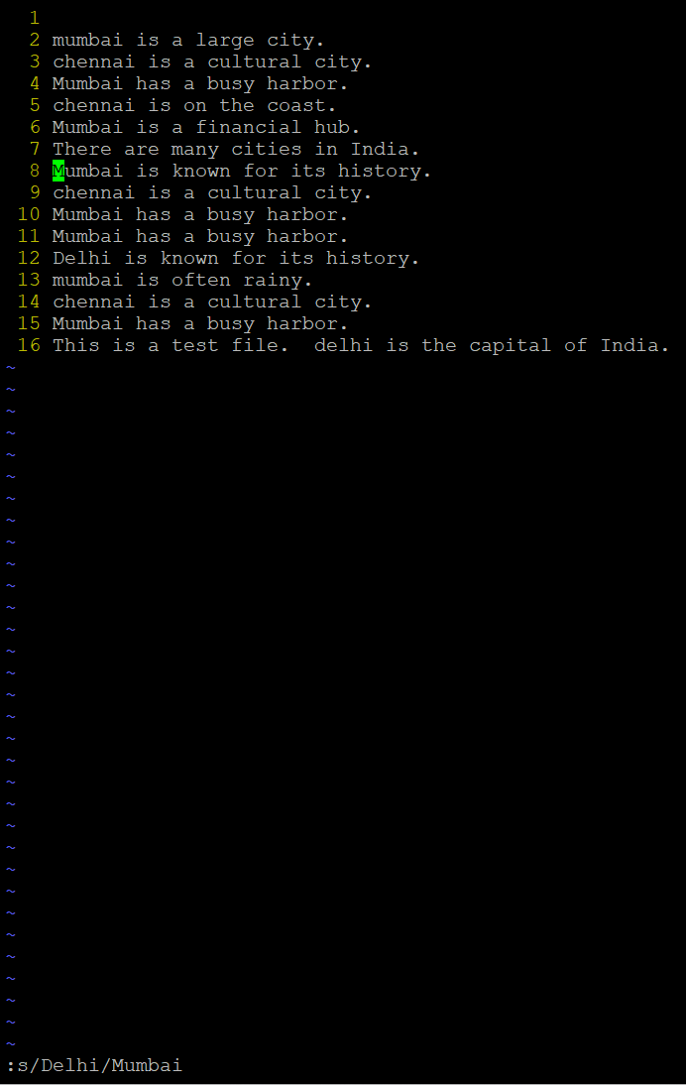
- Replace all occurrences of “delhi” on a particular line with “Mumbai” using one command
:s/delhi/Mumbai/g
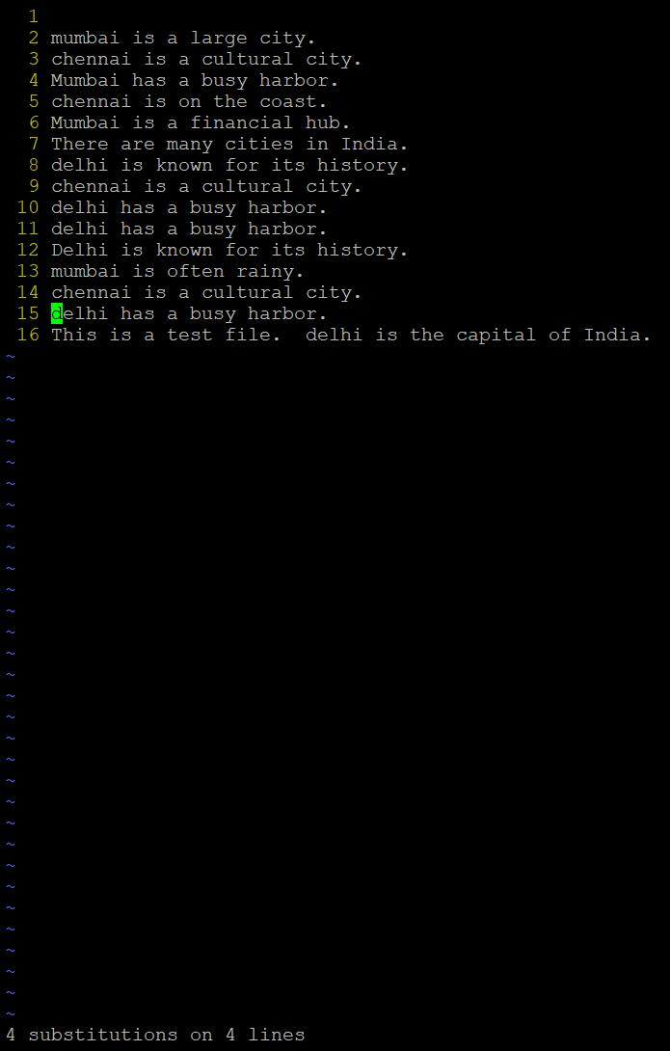
- Replace “delhi” with “mumbai” for the entire document using one command.
:%s/delhi/mumbai/15
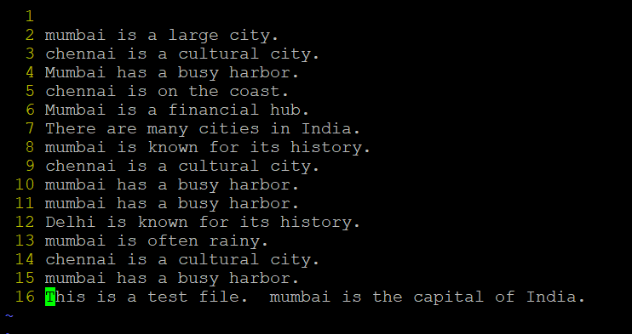
- Replace all occurrences of “delhi” with “mumbai” for part of a document (e.g. line number 13 to 37).
:10,13s/Delhi/mumbai/g
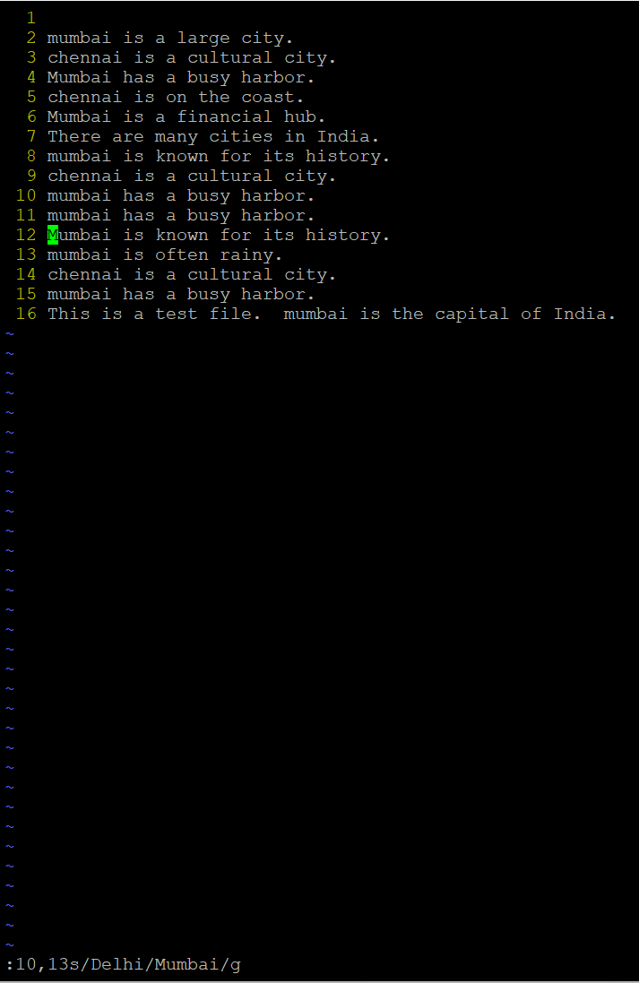
- Undo the above command
u
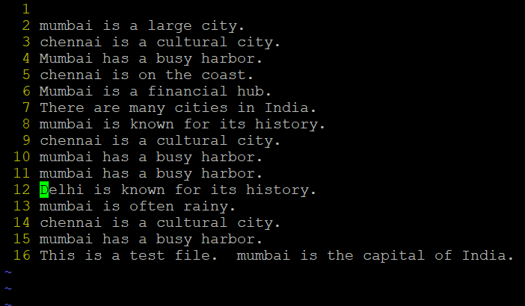
- Replace only the first occurrence of “delhi” with “mumbai” in each line, for part of a document (e.g. line number 13 to 37).
:10,13s/Delhi/mumbai/
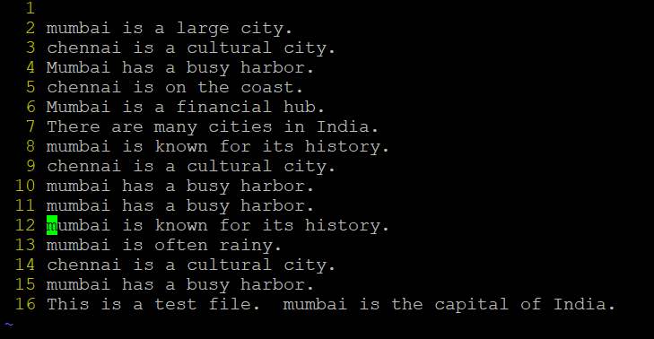
- Undo the above comment. Redo it. Undo it again.
Press u to undo.
Press Ctrl + r to redo.
Press u again to undo.
- Replace all occurrences of “delhi” with “mumbai” for complete file interactively.
:%s/delhi/mumbai/gc
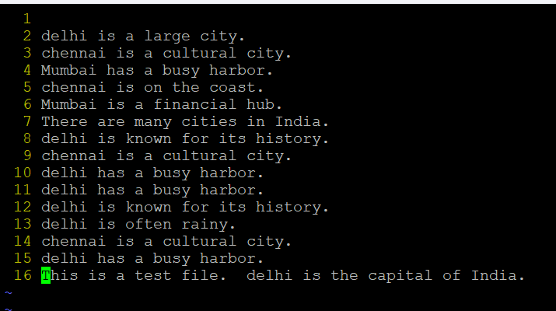
- Search for a word backwards. Loop through all matches.
?delhi
Press n to loop through matches in reverse order.
- Search for a word forwards. Loop through all matches
/delhi
Press n to loop through matches.
- Join two lines together.
J
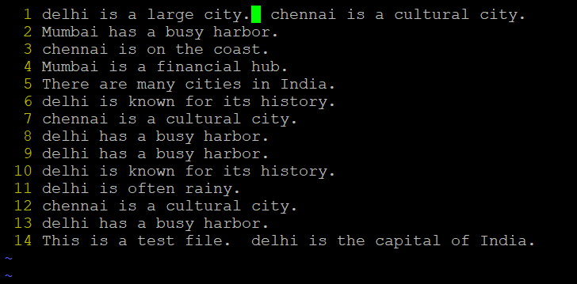
- Enable line numbering and then disable it
:set nu
:set nonu
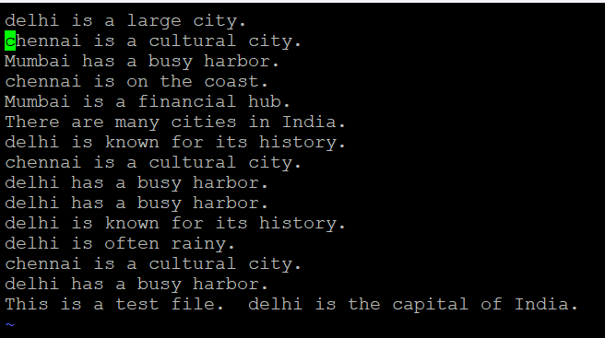
- Make the search case insensitive
:set ignorecase
- Delete 4 lines (and then paste them somewhere else)
To delete 4 lines: 4dd
Paste: p
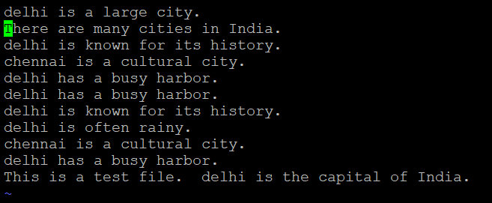

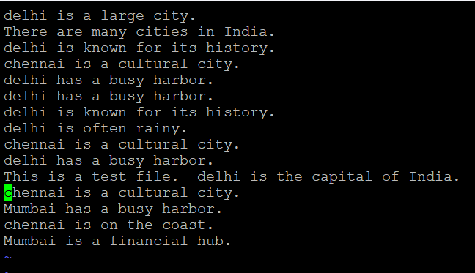

- What is the command to delete part of the line starting from the current cursor position?
d$
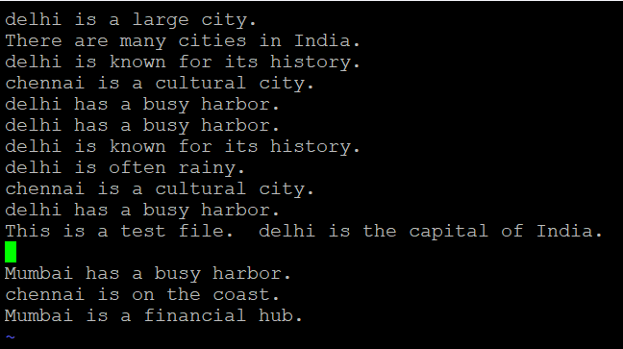
- What is the command to delete the current word?
dw

